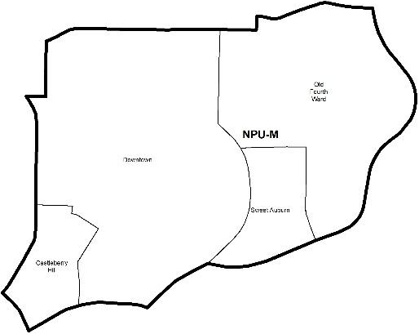

NEIGHBORHOOD PLANNING UNIT – M

MEETING INFO
Date & Time: Monday, January 28, 2019 – 6:15 PM
Location: Loudermilk Conference Center
40 Courtland St NE, Atlanta, GA 30303
CONTACT INFO
Rebecca Rice, NPU-M, Chairperson – (858) 248-1259 or chair@npumatlanta.org
Jon McKenley, City of Atlanta, Planner – (404) 546-0158 or jmckenley@AtlantaGa.Gov
Erica Pines, City of Atlanta, Asst. Director – (404) 546-0159 or epines@AtlantaGa.Gov
Keyetta Holmes, City of Atlanta, Interim Director – (404) 546-0166 or kmholmes@AtlantaGa.Gov

AGENDA
1. Opening Remarks/Introductions 6:20
2. Approval of Minutes Approved
3. Announcement
4. Reports from City Departmental Representatives
5. Comments from Elected Officials
6. Presentation(s)
- Westside Revive: Council District 3 Neighborhood Master Plan
- Atlanta Fulton Public Library: STEAM
7. Planner’s Report
8. Committee Reports
9. Matters for Voting

Special Event Application(s) – MOSE
Event Name | Event Organizer | Event Location | Event Date
SpeakEasy Football Frenzy  Motion to Not Support:  Approved – No Show | Joy Bailey | 156 Forsyth Street | January 31-February 3, 2019
Ingress ATL  Motion of Support:  Approved | Taren Henry | Woodruff Park | March 23-24, 2019
2nd Sunday Brunch Atlanta  Motion of Support:  Approved | Jim Shumake | Historic Fourth Ward Park | April 14-July 14, 2019
March for Babies  Motion of Support:  Approved | Hillary Dunson | Old Fourth Ward Park | May 4, 2019
The ACLU 100 Experience  Motion of Support:  Approved | Heather Gordon | Old Fourth Ward Park | May 5, 2019
Old Fourth Ward Arts Festival  Motion of Support:  Approved | Randall Fox | Historic 4th Ward Park | September 28-29, 2019

Liquor License Application(s) – LRB
Name of Business | Type of Business | Applicant | Property Address | Request
Blackbird  Motion of Support:  Approved | Restaurant | Asa Fain | 393 Marietta Street NW | New Business
City Winery Atlanta (Farm Winery)  Motion of Support:  Approved | Farm Winery | Philip J. Handley | 650 North Avenue SE | Change of Agent
City Winery Atlanta (Farm Tasting Room)  Motion of Support:  Approved | Restaurant and Farm Tasting Room | Philip J. Handley | 650 North Avenue SE | Change of Agent
Publix Supermarkets #776  Motion of Support:  Approved | Food Retail Package Store | Michael Frazier | 595 Piedmont Road | Change of Agent
Intown Market  Motion of Support:  Approved | Convenience Store | Surya Sankla | 349 Decatur Street SE | Change of Ownership
FellaShip  (Main and Mezzanine)  Motion of Support:  Approved | Restaurant | Cecil J. Newton | 110 Centennial Park Drive | Change of Ownership
McCormick & Schmick’s  Motion of Support:  Approved | Restaurant | Elvis Soto | 190 Marietta Street NW | Change of Agent
Pour Taproom  Motion of Support:  Approved | Restaurant | Ramon Ballester III | 661 Auburn Avenue | New Business
Hilton Garden Inn Downtown Atlanta  *Removed from Agenda | Hotel | Brian P. Bullock | 275 Baker Street | Additional Facilities

Zoning Review Board Application(s) – ZRB
Application | Property Address | Public Hearing Date
Z-18-136  Applicant seeks to rezone the .888 acre property from the C-2 (commercial service) zoning designation to the MRC-3 (mixed residential and commercial, maximum floor area ratio of 7.2) zoning designation to accommodate a mixed-use development featuring multi-family housing and ground floor commercial. SITE PLAN  Motion of Support:  Approved | 302 Decatur Street SE | February 7 or 14, 2019

Text Amendment(s) – Zoning Ordinance
Legislation | Public Hearing
Z-18-128 (Vote Required)  An Ordinance to amend the 1982 Atlanta Zoning Ordinance, as amended, by adding a definition for Adult Day Care Facility and by adding Adult Day Care Facility as a permitted use by special use permit in the R-1 (Single-Family Residential), R-2 (Single-Family Residential, R-2A (Single-Family Residential), R2B (Single-Family Residential), R-3 (Single-Family Residential), R-3A (Single-Family Residential), R-4 (Single-Family Residential), R-4A (Single-Family Residential), R-4B (Single-Family Residential), R-5 (Two-Family Residential), R-G (Residential General), and R-L-C (Residential Limited Commercial) zoning districts; and for other purposes. FACT SHEET  Motion of Support:  Approved – Conditioned on the parking requirement of (1) parking space per staff member | Zoning Review Board  City Hall Council Chambers  55 Trinity Avenue, 2nd Floor, City Hall | February 7 or 14, 2019

Public Notice
18-O-1673 (Information Only)
An Ordinance amending the 9-1-1 charge on prepaid wireline telephone service within the City of Atlanta and reaffirming a 9-1-1 charge on postpaid telephone service within the City of Atlanta; and for other purposes. MEMORANDUM
19-R-3007 (Information Only)
A Resolution naming the City Council Chamber “The Marvin Arrington, SR. City Council Chamber”; and for other purposes.

10. Old Business
11. New Business
12. Adjournment

